ENG 3U: Macbeth Unit Compare/Contrast Essay

For this essay assignment, you will write a compare/contrast essay that answers the question below.

Compare and contrast the development of Macbeth and Lady Macbeth before and after the murder of Duncan. What does each character’s development tell us about crime and punishment?

Requirements

Your essay must:

- be typed
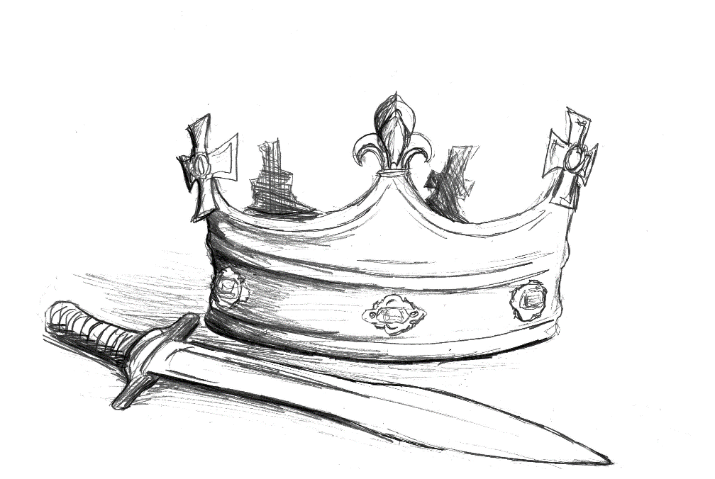
- be 1,000-1,200 words in length
- follow MLA guidelines for formatting
- be organized into an introduction, body and conclusion
- use either block or point-by-point for the organization of the body
- use standard, academic English
- contain and support a specific thesis
- use and analyze direct quotations from the play (short and long)
- include parenthetical references which respect MLA guidelines
- include a Works Cited sheet which respects MLA guidelines (NOTE: You must have a full citation for the Macbeth text as well as any secondary sources you consult for and use in your essay.)

Evaluation

Level  Category | Level 1 | Level 2 | Level 3 | Level 4
(K/U) Student demonstrates a comprehensive understanding of Macbeth and Lady Macbeth, making accurate statements about each character and using textual details to describe each character.  Student incorporates many relevant quotations, which are used to support ideas. He/she contextualizes and explains the quotations effectively. | rarely agree | partially agree | generally agree | strongly agree
(T/I) Student articulates a clear, specific, insightful thesis and supports it with logical and well-developed arguments.  He/she correctly many identifies similarities and differences in the development of Macbeth and Lady Macbeth. | rarely agree | partially agree | generally agree | strongly agree
(C) Student writes clearly and concisely. He/she avoid wordiness and awkward phrasing.  Language conventions are respected, and mistakes in language conventions do not interfere with reader comprehension. | rarely agree | partially agree | generally agree | strongly agree
(A) Student applies MLA guidelines for formatting. Parenthetical references are used correctly, and the Works Cited sheet is mistake free.  Student organizes the essay effectively. He/she applies either block or point-by-point organization effectively. He/she includes an introduction which is organized from general to specific and a conclusion which is organized from specific to general. Body paragraphs begin with a clear main idea and end with transitions to the next main idea.  He/she uses a formal, academic style which suits the purpose of a literary essay. There is no slang or colloquialisms. | rarely agree | partially agree | generally agree | strongly agree

Compare/Contrast Graphic Organizer

 | Macbeth | Lady Macbeth
Before the Murder
During the Murder
After the Murder

