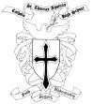
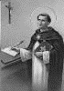
ST. THOMAS AQUINAS CATHOLIC HIGH SCHOOL
1211 South Russell Road, Russell, Ontario K4R 1E5
Principal: Mr. Danny Palumbo
Vice-Principal: Mr. Dean Doucette
Phone Number (613) 445-0810 Toll Free 1-877-559-7729 Fax Number (613) 445-1520 Web site: www.sta-russell.com

‘FAITH SEEKING UNDERSTANDING’

Recommended School Supplies: Grade 7 & 8
- Pencils (24)
- Erasers (8)
- Pens (blue or black)
- Clear Plastic Ruler
- Scientific calculator (other electronic devices cannot be substituted for a calculator)
- Geometry Kit
- Markers
- Pencil Crayons
- Scissors
- Glue Sticks
- Grid Paper
- Lined Paper (800 pages)
- ONE binder (1.5”-2”)
- 8 Subject dividers that can be labelled
- Good quality lock; Abus or Master brand locks seem reliable (no key locks permitted)
- Pencil Sharpener (with enclosed compartment for shavings)
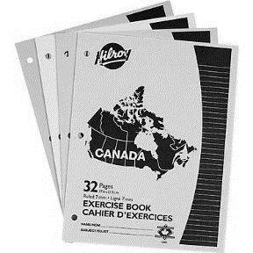
- Highlighters
- Correction Tape (not liquid white-out)
- Silent Reading book
- Pocket French/English Dictionary
- 4-pack 32 page Hilroy Exercise Books (or similar)

Notes:
- Please label all uniform items with your child’s name.
- Please check in with your child over the course of the school year to ensure supplies are replenished as needed.

