Labour Unions
A hundred years ago, children didn’t go to school very often or for very long, unless their parents were rich. They might have gotten to grade three or “third book”, learning how to add and subtract, how to read simple things and how to sign their names. After that, most of them left school and got jobs to help support their families. They worked in mines, mills and factories. In the early days of industry, most people worked twelve hours a day. They worked for very low wages such as twenty-five cents a day. Working conditions were often dangerous and those who complained were fired. No matter what your job, it was dangerous. There were no safety rules, protective clothing, goggles, hard hats or guards on machinery. Thousands of working men, women and children lost their health, limbs, eyes and too often their lives. Here’s a true story about one of them:
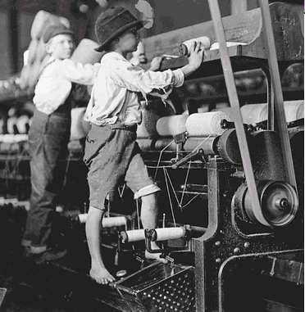
“My name is John Gale. I’m seventeen, and I haven’t had steady work for five years now. Nobody wants to hire on a fellow like me, who’s missing his right arm. I’m a hard worker, too. Leastways I was. I had a good job over in the sawmill on the bay. My dad got me in there before I was eleven, and I was making twenty-five cents a day. I worked at the circular saw, the tow-footer, taking away the rough ends of the planks as they got trimmed. To this day I’m not sure what happened, but my arm got caught in the big cog-wheel that drives the machines and chewed it up like it was a sausage. I fainted dead away, right there in the sawdust. It happened just after the noon dinner whistle, but we had a good boss and I got paid for the whole day. Anyhow I’m not as bad off as some. It wasn’t two months later that another boy at the mill got both his arms and his legs taken off.”
- Pay Cheques and Picket Lines by Claire Mackay

In the nineteenth century, working people had few laws to protect them. Wages were low. Hours of work were long. You could be fired for any reason or for no reason. If business was slow, you were laid off. Your pay stopped. Too sick to work? Too bad. Your pay stopped. Hurt on the job? Tough luck. Your pay stopped. Too old to work? No pay; no pension either.

Most people accepted this. They thought it was just the natural order of things, or fate, or the will of God. Some people were rich. Some people were poor. If you were born poor, you’d be poor all your life, and you’d die poor. So you worked as long and as hard as you could, took the pay the boss gave you, and figured you were lucky to get it. If you ever got a raise, you were really lucky.

A few dozen people had most of the money and all of the power. Tens of thousands of people had barely enough money to eat every day – no power at all.
- Workers started to think this was unfair.
- Then they started to get angry.
- Then they started to talk about what they could do.

Then workers on some types of jobs formed groups. These groups were called unions. Workers in a union stuck together. The union leaders spoke for all the workers, so employers listened. Today, many factory workers belong to unions. Many in skilled trades, like carpenters and plumbers, belong to unions. There are unions for many other types of work, too. The main benefits to union members today are:
- Provisions for professional training
- Legal advice
- Representation for members

Still, employers and workers disagree sometimes. Workers may want more money. They may want fewer hours, or they may want better conditions. Union leaders and company managers try to settle the problems. They sit down and talk. Each side has to give a little. This is collective bargaining. When they agree, they sign a labour contract. It covers wages, hours of work, and working conditions.
We sometimes forget that eight-hour days, minimum wages, workers’ compensation and regulations prohibiting the exploitation of child labour were victories won by ordinary working people and their unions. Less than one hundred years ago, most Canadians lacked any form of protection in the workplace.

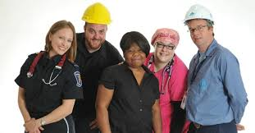
The Law & Unions
When a majority of people in a given workplace decide they want to “unionize” themselves, they must go through a legal process that’s strict and specific. Labour Relations Boards in each province administer their Labour Relations Acts. These Acts outline what individuals must do to join a union, what the union must do to win the right to represent those people, and what the employers must do to have a responsible relationship with the union.
If the majority of workers eligible to join the union want to join, they certify the union to represent the workers. Union and management then bargain to reach a collective agreement.
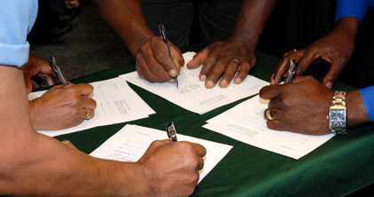
Collective Agreements

Every year in Canada, 1,500 workers are killed on the job. About 12,000 people die of work-related cancer and another 20,000 are permanently disabled by workplace chemical accidents.
Unions try to bargain strong collective agreements to counter these and other problem. Collective agreements are not easy to get. They demand a lot of compromise, a lot of give and take. But once agreed to, they are legally binding and are enforced by law.
Collective agreements set out the following:
- working conditions;
- wages;
- vacations;
- hours of work; and usually
- medical, dental and pension plans.
Recently, some unions have added clauses on:
- technological change;
- child care;
- equal pay for work of equal value;
- affirmative action;
- part-time work; and
- freedom from sexual harassment.

History of Unions in Canada
• Labour unions have existed in Canada since the early 1800s. There is a record of skilled tradesmen in the Maritimes having a union organization during the War of 1812.
• Canadian unionism had early ties with Britain. Tradesmen who came from Britain brought traditions of the British trade union movement, and many British unions had branches in Canada. Canadian unionism ties with the United States eventually replaced those with Britain.
• A key development in the growth of unionism came in 1872 when printers in Toronto went on strike for a nine-hour-day. Union activity was illegal at the time, and many prominent labour leaders were arrested. Mass protests ensued, resulting in the dropping of charges and the legalization of union activity.
• The first national labour organization was formed in 1873 at a national convention in Toronto. The organization later became the Trades and Labour Congress of Canada in 1883, a forerunner of the present Canadian Labour Congress.
• The early 1900s saw massive escalations in labour activity as workers demanded universal eight hour days, union recognition and better wages. Between 1919 and 1920 there were over 1500 strikes involving an estimated 375,000 workers. The largest of these was the Winnipeg General Strike of 1919, which involved over 25,000 Winnipeg workers. The government used strike breakers, police and army to violently end the strike.
• The early 1900s also saw the development of labour politics. In 1921 the Communist Party of Canada was founded, and in 1932 the Co-operative Commonwealth Federation was created. Both parties supported worker rights and were critical of capitalism. The Co-operative Commonwealth Federation eventually became the New Democratic Party.
• Collective bargaining was first recognized in 1937, following a strike by the United Auto Workers at the General Motors' plant in Oshawa, Ontario.
• Justice Ivan Rand issued a landmark legal decision following a strike in Windsor, Ontario, involving 17,000 Ford workers. He granted the union the compulsory check-off of union dues. Rand ruled that all workers in a bargaining unit benefit from a union-negotiated contract. Therefore, he reasoned they must pay union dues, although they do not have to join the union.
• The post-World War II era also saw an increased pattern of unionization in the public service. Teachers, nurses, social workers, professors, and cultural workers (those employed in museums, orchestras, and art galleries) all sought private-sector collective bargaining rights.
• In the 1970s the federal government came under intense pressures to curtail labour cost and inflation. In 1975, the Liberal government under Prime Minister Trudeau introduced mandatory price and wage controls. Under the new law, wages increases were monitored and those ruled to be unacceptably high were rolled back by the government.
• Pressures on unions continued into the 1980s and 90s. Private sector unions faced plant closures in many manufacturing industries and demands to reduce wages and increase productivity. Public sector unions came under attack by federal and provincial governments as they attempted to reduce spending, reduce taxes and balance budgets. Legislation was introduced in many jurisdictions reversing union collective bargaining rights, and many jobs were lost to contractors.

Use these links to listen or view the broadcasts related to questions in Part B of the question sheet.
Question 1) http://www.cbc.ca/archives/entry/shedding-light-on-the-rag-trade
Question 2) http://www.cbc.ca/archives/entry/garment-workers-first-strike-in-four-decades
Question 3) http://www.cbc.ca/archives/entry/the-garment-industry-working-at-night

