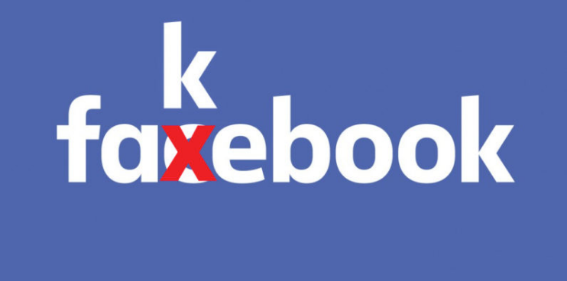
Fake News on Facebook
Type your answers to the following questions below each question.
- How would you define fake news?

[answer]

- In the lead-up to the Brexit referendum in 2016, how did the Vote Leave campaign use Facebook to target voters?

[answer]

- Were the messages posted on Facebook by the Vote Leave campaign fake news?

[answer]

- How was Facebook used to sway voters in the 2016 presidential election? What’s a “bot”? How were Russian bots used to influence voters?

[answer]

- At first, how did Facebook respond to criticism that fake news was being posted on the site and that Facebook influenced the presidential election?

[answer]

- Summarize Mark Zuckerberg’s New Year’s resolution to fix Facebook. To what problems does he allude? How does he intend to fix these?

[answer]

- How did fake news lead to mob lynching in India?

[answer]

- After reading the article which appeared in Wired, provide examples of different types of fake news and how it would effect its victims.

Description of Victim | Site (Facebook, Instagram, etc.) | Description of Fake News | Effects on the Victim

