Causes of the Industrial Revolution in Britain
I. Agricultural Revolution
A. New crops from New World
1. corn
2. potatoes
B. New farming methods
1. Enclosure
a. laws passed by British Parliament
b. land owners able to practice new farming methods
c. no more "common lands"
(1) smaller farmers forced out of rural areas and into cities
2. New farming technologies and knowledge
a. crop rotation and soil mixing
b. turnips used to replenish soil
c. seed drill (machine that planted seeds deeper and at regular intervals
II. Domestic System (Cottage Industry)
A. small-scale industry
1. farmers in their homes to supplement income
B. production of textiles (cloth) made of wool
C. men, women and children became skilled in various stages of production
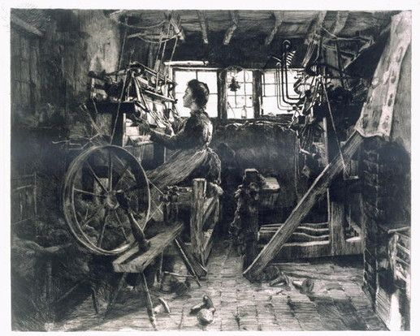
1. spinning
2. weaving
3. dying
III. New economic conditions
A. increase of trade and demand for manufactured products
B. capitalism
1. Wealth of Nations by Adam Smith
2. key ideas:
- promoting trade will increase human happiness
- pursuing self-interest will make society prosper
- division of labour is more efficient and profitable
3. laissez-faire approach to economy

IV. Abundant natural resources and food
A. lots of coal and iron deposits
B. waterways
1. harbors and rivers (transportation)
2. rivers (natural power for mills)
C. Britain's colonies supply raw materials
1. cotton from India
D. more food due to Agricultural Revolution
V. Large labour supply
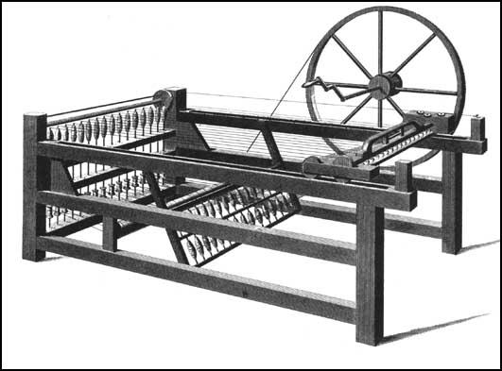
A. rapidly growing population
B. rural exodus to cities
1. as a result of enclosure
2. people with experience working with textiles
VI. Favourable government
A. laws promote investment in business
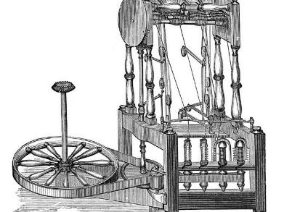
VII. New inventions
A. Spinning Jenny (1764)
B. Water Frame (1769)
C. Spinning Mule (1779)
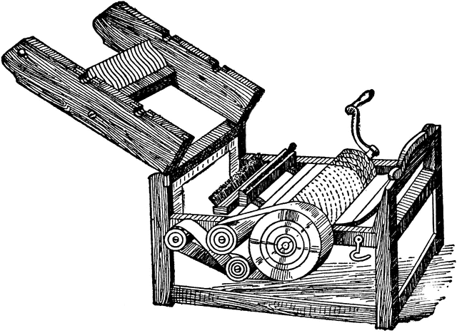
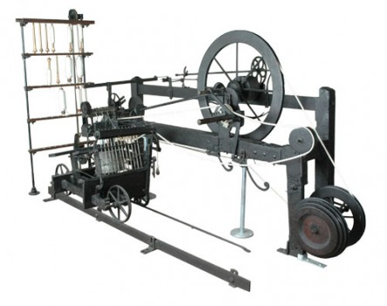
D. Steam Engine (1882)
E. Cotton Gin (1793)
VIII. Inventions to speed transportation
A. locomotives/railroads
1. e.g., "The Rocket" (Liverpool to Manchester railroad)
B. canals and steamboats

